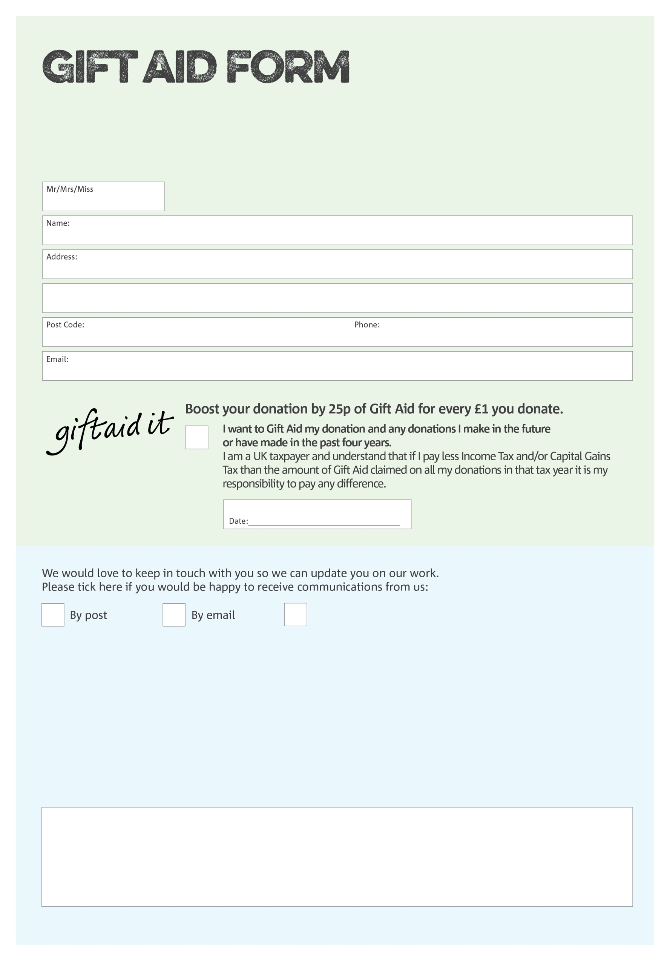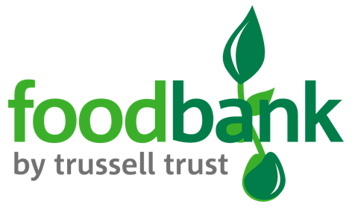

By filling in this form Horsham District Foodbank will receive an extra 25p for every £1 you give at no extra cost to you. Thank you!

**Data protection**

*Horsham District Foodbank is committed to protecting your privacy and will process your personal data in accordance with current Data Protection legislation. Horsham District Foodbank collects information to keep in touch with you and supply you with information relating to our work. To unsubscribe from our newsletter, send a message to the email address above with the word unsubscribe in the subject line. A full data privacy statement for financial donors is available from the foodbank on request.*

You can change your preferences any time by contacting us on 0300 124 0204 or emailing us at

info@horshamdistrict.foodbank.org.uk

I do not wish to receive future communications from Horsham District Foodbank

We would love to know why you have chosen to donate to Horsham District Foodbank. If you would like to share your motivation let us know below:

Horsham District foodbank is run by Horsham Matters, Charity Number 1116253.